|  |
| --- |
| BLUEsat – UNSW Student Satellite Project  Document BLUE.2011.1.0 |
| BLUEsat Primer |
| An introduction to the BLUEsat Student Satellite Project |
| **Authors and Contributors:**  Thien Nguyen – Chief Technical Officer 2011  Mitch Wenke  **Date:** |
| September 24, 2011 |

# Introduction

The purpose of this report is to consolidate the design of BLUEsat into a single document. The intention is that, by reading this particular report, the reader will be able to gain an overview of the nature of the BLUEsat project, its mission, project management philosophy and a brief technical overview of the design of the satellite itself.

Whilst this report contains some amount of technical detail regarding the design of the satellite, it is not intended to be a fully detailed technical master file. The rationale and overall design of each sub-system will be described such that the reader understands the nature of the satellite itself and how each system is related to each other. For a fully detailed technical report regarding the design of the satellite and current development progress, please consult document BLUE.2011.2.0 – BLUEsat Technical Design Report.

# Table of Contents

1 Introduction 1

2 Table of Contents 2

3 Table of Figures 2

4 Project Background 3

5 Project Management and SCRUM 4

6 Satellite System Overview 5

6.1 Specifications 5

6.2 System Design 5

6.3 Mechanical Structure 7

6.4 Critical Systems Computer 9

6.5 Power 11

6.6 Communications 13

6.7 Telemetry 14

6.8 Payloads 15

# Table of Figures

Figure 6.1 – Satellite Systems Overview 6

Figure 6.2 Exploded view of the satellite tray system 7

# Project Background

# Project Management and SCRUM

# Satellite System Overview

BLUEsat’s intended purpose is to service the Amateur Radio community whilst being a vehicle for experimental payloads. That is, the satellite is to assist in communications between members of the Amateur Radio Community worldwide, whilst also allowing simple payloads to conduct experiments in space.

To that end, the satellite is physically designed much like other Amateur Radio Microsatellites - with much inspiration taken from ECHOsat (AO-51). The satellite is composed of trays in which will contain communications peripherals and the processing units which are responsible for the (relatively) autonomous operation of the satellite.

## Specifications

In order to function as a useful Amateur Radio Satellite, the satellite needs to be able to do the following (listed in increasing complexity but decreasing criticality)

1. Function as an Analogue Repeater
2. Function as a Digital Repeater
3. Be able to store and forward Data (PACsat)

On top of this, the satellite needs to survive autonomously in Low-Earth Orbit (at an altitude of approximately 750km). This means that that along with the above functionality, the satellite must

1. Be able to power itself
2. Survive in a Vacuum
3. Survive the Radiation in a Space Environment
4. Be able to evaluate its own state

## System Design

The satellite itself is split into two main systems, each with its own central processing unit - the Payload Systems and the Critical Systems. Figure 6.1 illustrates the basic system overview and interconnectivity between systems within the satellite.

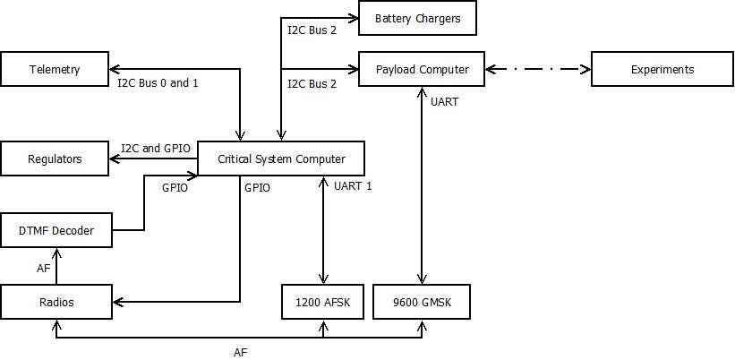

Figure .1 – Satellite Systems Overview

The Critical Systems deal with the basic functioning and survival of the satellite, as well as performing basic Analogue repeating. Critical Systems is responsible for powering the different electrical systems, monitoring the health of the satellite and maintaining basic communications with Earth. To that end, the Critical Systems is composed of

* The Critical Systems Computer (CSC)
* Telemetry System
* Communications System
  + Radio Transmitter and Receiver
  + 1200 baud AFSK Modems
* Power Distribution System
* Solar Array and Battery Charging System,

The Payload system consists of the Payload Computer and the experimental Payloads themselves. The Payload computer is to act as an interface between the Satellite’s Payloads and the Critical systems. The Payload computer also provides a separate modem (the 9600 baud GMSK modem) to allow for higher speed communications with the Groundstation.

The Payload system was made distinct from the Critical Systems to allow for greater modularity in the overall design of the satellite. To this end, integration of payloads will not greatly affect the design of the critical systems of the satellite.

## Mechanical Structure

The Satellite’s Mechanical design is based off of other similarly sized Amateur Radio Microsatellites, with particular inspiration taken from ECHOsat (AO-51). The satellite is composed of five square trays stacked vertically to create a 250x250x250mm cube with a Solar Panel on each of the 6 sides.

The trays will contain the electronic circuitry of the satellite. There are connectors attached to the backplane of the satellite in order to allow for connections between trays. The trays (from top to bottom) are assigned electronics as follows (referencing Figure 6.2)

* Tray 5 - Radio Receiver and Hybrid Coupler
* Tray 4 - Payload Computer and Payload Systems
* Tray 3 - Batteries
* Tray 2 - Critical Systems and Power Systems
* Tray 1 - Radio Transmitter and Hybrid Coupler

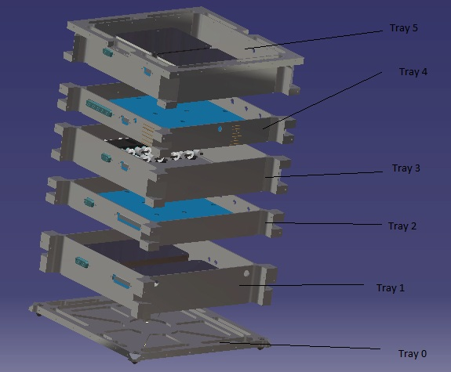

Figure .2 Exploded view of the satellite tray system

Trays 5 and 1 have specialised mounting holes and covers in order to attach and shield the Radio units. Trays 4 and 2 are designed to maximise the amount of surface area available for printed circuit boards. Tray 3 is designed to allow for mounting of two battery packs that is to make up the battery array.

Once assembled, the trays allow for attachment of flat panels on each side, onto which the Solar Arrays will be mounted. The top and bottom panels will have allowance for Antennae footholds for radio transmission.

Detailed drawings and design rationales can be found in document BLUE.2011.2.0 – BLUEsat Technical Design Report.

## Critical Systems Computer

The critical systems on the satellite (being the Communications, Telemetry and Power systems) will be controlled via a central micro-controller and memory system complete with a multi-threaded Operating System. This central controller is called the Critical Systems Computer. This system is to be distinct from the Payload Computer, whose responsibilities lie solely in interfacing with BLUEsat’s payloads.

The microcontroller central to the design of the Critical Systems Computer is the ARM7 LPC2468 manufactured by NXP Semiconductors. On this microcontroller, BLUEsat will run a distribution of FreeRTOS (Free Real-Time Operating System), modified for the specific operational needs of the satellite.

Within the operating system, drivers and applications are intended to be run in order to control the critical systems of the satellite according to pre-defined constraints. These applications and drivers will be incorporated into the central computer ‘system’ according to the architecture outlined in document BLUE.2011.2.0 - BLUEsat Technical Design Report.

The critical systems computer will run according to commands received from earth via transmission of nine digit codes transmitted in Dual Tone Multi Frequency (DTMF) format.

The Critical Systems Computer will directly perform the following tasks

* Power Systems
  + Voltage Regulator Control
  + Battery Charge Regulator Control
* Telemetry data request and storage
* Communication
  + RX and TX Radio control
    - Power regulation
    - Line switching
  + AFSK (low speed) data transmission

## Power

The BLUEsat Power system is divided into three sub-systems, the Solar Array, the Battery Charge Regulator and Voltage Regulators.

The current design for Solar Array consists of six solar panels. Each panel will sit 14 Gallium Arsenide solar cells connected in series. These six panels will sit on each of the six sides of the satellite, as illustrated in Figure 6.3.

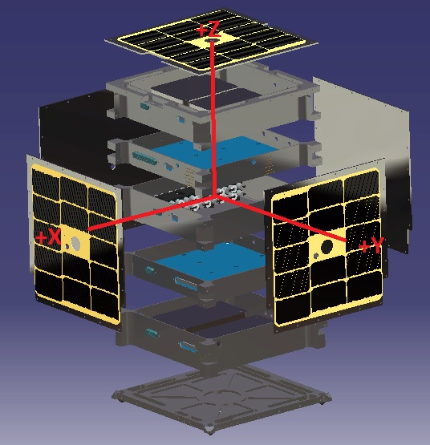

Figure .3 Exploded view of Satellite structure including solar Array

This array will feed power into the Battery Charge Regulator which regulates power into the battery array. The battery array currently consists of four strings of eleven Nickel Metal Hydride (NiMH) batteries, outputting a total of 13.2V. Power from this battery array then gets passed to the Voltage regulators, which distribute power to the different subsystems of the satellite. Figure 6.4 illustrates the flow of power from solar panels to each electrical subsystem in the satellite

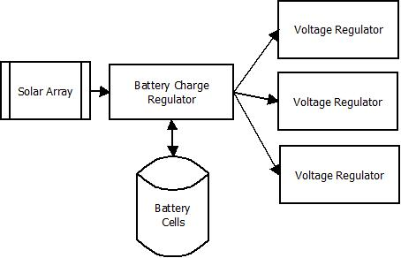

Figure . - Simplified overview of the Satellite Power System

The power system has been designed such that the Critical Systems computer is able to monitor and modify the state of the charging circuit, as well as being able to shut off power to different parts of the satellite

## Communications

BLUEsat will communicate with Earth via VHF radio transmitters and UHF radio receivers. Digital data from the Critical Systems Computer and Payload Computer will be modulated by AFSK (Audio Frequency Shift Keying) and GMSK (Gaussian-Minimum Shift-Keying) modems, respectively, for transmission or reception by the radios.

In addition to this the satellite will also process commands in the form of nine digit numbers, transmitted in DTMF (Dual-Tone Multi-Frequency) form. These commands will be decoded by a DTMF decoder for processing by the Critical Systems computer.

These communication lines will be controlled by a central switching circuit. This switching circuit will be used to implement a hierarchy according to which communication lines need to be used to transmit and receive.

### Radio Modules

### Antennae

### AFSK Modem

### GMSK Modem

### Beacon

The beacon was designed by a random polish guy. As such we think the circuitry incorporates some form of explosive, and we are afraid to launch the satellite with it on. However, he wields a mighty hammer everytime he comes into groundstation, so we fear going against his word.

## Telemetry

## Payloads

### Payload Computer

### EDAC

### Namuru